**2023 Athletic Field and Sports Court**

**Tournament Guidelines**

**Revised 2/9/23**

Thank you for considering the City of Richland for your upcoming sports tournament. Please take a few minutes to review all the attached information as it will make your experience with us more enjoyable. For questions and assistance please contact:

Stan Johnson - **sjohnson@ci.richland.wa.us** or 509-942-7541

**To submit an application complete the electronic application linked on the Parks and Recreation website at www.richlandparksandrec.com**

Please follow the steps below to allow adequate time for processing and preparation for your field needs.

**Read the Athletic Field and Sports Court Usage Guidelines**. If you have any questions please contact us at 509-942-7529.

**Complete the following items** and submit them at least 28 days prior to the date of your first field use.

**The Application Checklist:**

Submit online application link at richlandparksandrec.com

After application approved

Pay application fee of $89.00 per tournament

Submit refundable damage deposit of $297.00/complex

Submit Certificate of Insurance **with endorsement**

**Spring/Summer Season: March 1st – July 31st**

* Applications open November 1st to December 14th. Applications will be received for open dates throughout the summer.

**Summer/Fall Season: August 1 – October 31st**

* Applications open November 1st to June 14th. Applications will be received for open dates throughout the year.

**Tournament Fees**

Tournament Application Fee: $89.00/tournament

Refundable Damage Deposit: $297.00/Complex

**Softball/Baseball Tournaments Fees:**

Full Day Tournament (more than 8 hours)

Columbia Playfield $1,069.00 per day

Horn Rapids or Badger Mountain $831.50 per day

Half Day Tournament (8 hours or less)

Columbia Playfield $594.00 per half day

Horn Rapids or Badger Mountain $475.25 per half day

Full Day and Half Day tournament fees include: Facility rental, City staff used for grooming, bathroom clean-up, lights, emptying of trash cans and 5 bags of field conditioner if needed.

**Other Potential Tournament Fees**

**Resident Field/Court Fee** (2 hour minimum)

Non-lighted Fields $ 6.25 per hour

Sport Court Fees $ 6.25 per hour

**Non-Resident Field/Court Fee** (2 hour minimum)

Non-lighted Fields $ 8.50 per hour

Sport Court Fees $ 8.50 per hour

**Field Lights**– any length of time $24.25/field/night

The lights will be schedule to turn on no earlier than 30 minutes prior sunset unless otherwise requested.

**Outfield Temporary Fencing** at Horn Rapids only $118.75 per field

**Event Support Staff at Sports Fields** (2 hour min) $ 24.75 per hour

**Ballfield Crew Day (**6 am – 3:30pm- 2 hour min) $ 71.75 per hour

**Ballfield Crew Afternoon** (After 3:30pm - 2 hour min) $105.00 per hour

**Maintenance Staff Day (**6 am – 3:30pm- 2 hour min) $ 67.75 per hour

**Maintenance Staff After Hours** (After 3:30pm - 2 hour min) $92.25 per hour

**Infield Groom only** $30.00 per field

**Infield conditioner** ballfields only when raining $17.75 per bag

(first 5 bags of field conditioner included in tournament fee)

**Beach Volleyball Court Grooming** $58.50 for 3 courts

**Tournament Fees** are required to be paid within 15 working days after the tournament is completed. Payment can be made at the Parks & Public Facilities Office, 500 Amon Park Drive or online as described on your invoice.

**Definition of Terms**

“**Responsible party**” is defined as the activity organizer, promoter or representative responsible for organizing the public or private use activity within any City of Richland park or facility. The Responsible Party shall be 18 years of age or older.

“**Athletic Field Use Permit**” is defined as a contract/reservation agreement issued by the City. A permit is required for any organized activity involving the use or having impact upon the parks facilities or grounds.

“**City”** means the City of Richland

**“Community Events”** means those events where the general public is invited to attend and no entrance fee or participation fee is required.

**“Department”** means the City of Richland Parks and Public Facilities Department

**“Historic Use”** means organizations who have scheduled sport fields during the most recent prior season for a particular sport.

**“League play”** means the practices and games scheduled with participants who have been solicited through a publicly advertised manner and no one is turned away from participating.

**“Maintenance Staff”** means the City of Richland Parks and Public Facilities Maintenance staff.

**“Private Events”** means those events where participants are selectively invited to participate or where a fee is charged to participate.

**“Organization”** means any entity requesting use of a sports field whether it is a league, group, association or individual team.

**“Resident”** means someone who resides within the city limits of Richland.

**“Select teams”** mean those teams made up of participants who have been selectively chosen and a publicly advertised solicitation has not occurred.

**“Athletic Field”** means those fields identified in this document.

**Terms and Conditions for Use of Athletic Fields**

The following rules and regulations will be in effect for all City of Richland athletic fields and sports courts. The Responsible Party will adhere to all park rules and regulations and will insure all field use participants do as well.

**Reservations of Use Dates**

Preference for scheduling shall be given in the following order:

* 1. Leased facilities
  2. City of Richland operation/maintenance/events/programs; tournaments solicited by the City and City co-sponsored events or programs
  3. Governmental Agencies/Richland School District: conducting events or activities designed to serve the citizens and businesses of Richland and tournaments that increase tourism.
  4. Organizations with which the City has Facility Use Agreements
  5. Historic user’s youth sports leagues
  6. New tournaments with a tourism component
  7. Richland youth sports league leagues
  8. Richland resident youth Select Teams games and practices
  9. Richland resident adult sports leagues and all other tournaments
  10. Richland residents & Richland non-profit businesses for non-commercial use
  11. Resident for-profit Businesses: Must have a building within the City limits.
  12. Non-residents; non-resident select teams, non-resident league play and Non-resident non-profits:
  13. Non-resident businesses

The City will not typically schedule any use of sports fields during the months of November, December, January and February. Each request during these months will be considered on an individual basis.

**Though park hours begin at 5:00a.m., games shall not start before 8:00 a.m. and all games shall be completed by 11:00 p.m. Applications for tournaments operating outside these hours will be considered on a case by case basis.**

Due to limited field availability the City cannot always guarantee that you will receive all the field times that you have requested.

List of reservable fields in the City Facilities Chart.

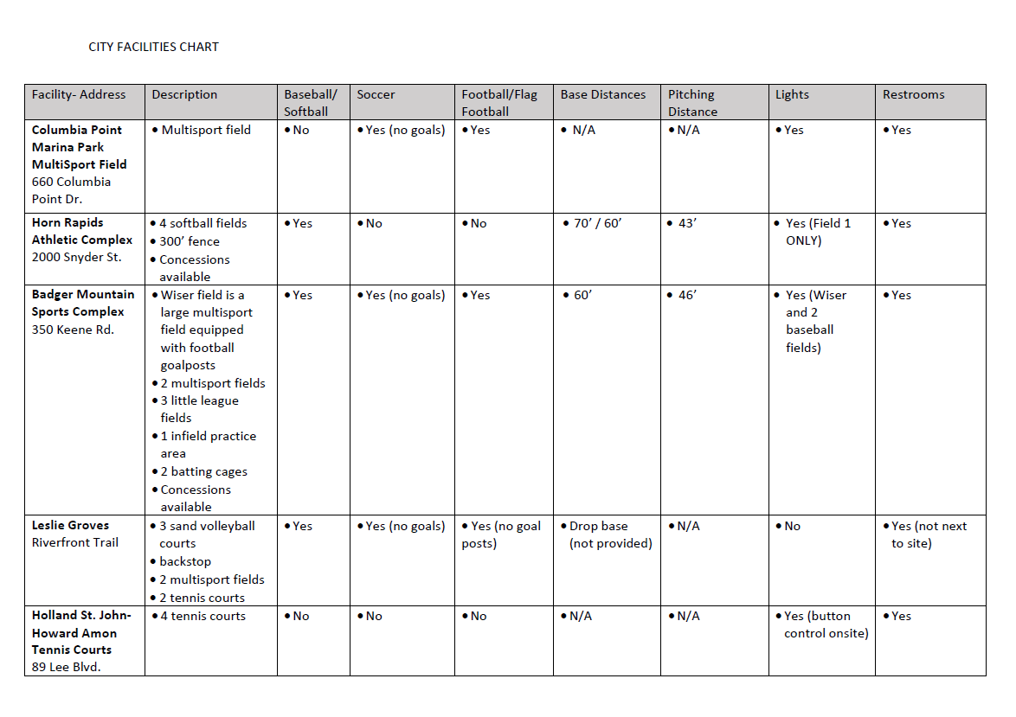

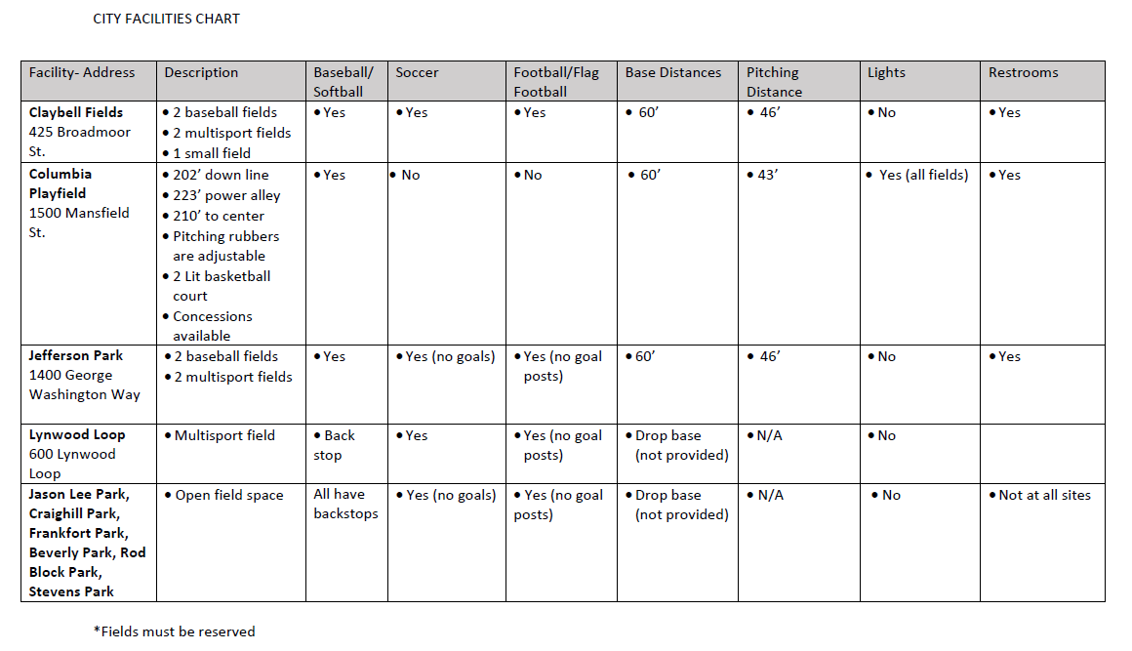

**Hold Harmless**

This language will be included in your facility use permit and is provided here for your information. Your facility use permit will require signature of the following: “In consideration for granting this request, and being fully aware of all of the risks, the Organization and/or Individual hereby RELEASES the City of Richland and its officials, employees, volunteers and agents (“the Released Parties”), and AGREE TO WAIVE ANY RIGHT OF RECOVERY THAT I AND/OR THE ORGANIZATION, AS APPLICABLE, MAY HAVE, including the right to bring a legal claim, cause of action, or lawsuit for any bodily injury, death or other harmful consequences in any way arising out of use of the Facilities. I understand that this release extends to all claims of any kind and every nature, known, unknown, suspected or unsuspected, in any way arising out of or related to use of the Facilities.

The Organization and/or Individual agrees to defend, indemnify and hold harmless the Released Parties from and against any and all claims, suits, actions, or liabilities for injury or death of any person, or for loss or damage to property, which arises out of the use of the Facilities or from any activity, work or thing done, permitted, or suffered by Applicant in or about the Facilities, except only such injury or damage as shall have been occasioned by the sole negligence of the Released Parties.”

**Facility Use Fees**

Fees are charged to provide for recovery of the cost to City taxpayers for administrative and maintenance costs associated with exclusive use requests of park facilities. Fees include the cost for application processing, administration, maintenance, utilities, space and/or facility use and in some cases, fire, police, public works and other miscellaneous expenses.

**Field Use Cancellation Policy**

Field use cancellation must be made in writing (email is acceptable) at least 7 business days prior to scheduled field use. Failure to do so will mean forfeiture of the field use fees for all fields not used. Fees will be refunded if the City has to close the fields for a safety reason or the City determines that the fields are unplayable due to weather conditions. Once field use has begun, you are responsible for the payment for all field fees and games that were completed or partially completed before the rainout or field closure.

**Field Conditions & Maintenance**

The Responsible party will accept the premises in its present condition and at the times designated on the facility use permit.

1. Field users are responsible for clean-up of their participant(s) use area, litter removal (including but not limited to seed shells and plastic bottles) and removing all equipment and materials after use. If any additional clean-up work is required to be performed by City Staff, the cost will be deducted from the damage deposit.
2. The field area used by the Responsible Party shall be free of litter each day prior to leaving the facility. All equipment brought in by the responsible Party shall be removed at the conclusion of the last game/practice.
3. The level of service for field maintenance shall be negotiated with the City and Organization prior to the beginning of field use.
4. Fields shall not be used while maintenance activity is occurring on the field.
5. The City reserves the right to limit the amount of scheduled and non-scheduled play on athletic fields during any given season to prevent excessive damage to turf.
6. Field Closure/Rainouts – The Department will have the final authority regarding the play-ability of the fields. During inclement weather or hazardous air quality issues please call 509-942-7529 for field closure information.
7. Closures may result from poor playing conditions that could cause safety hazards for the public and/or damage to City property that could result in excessive repair work to bring the field back to a playable condition or poor air quality conditions.
8. The Responsible Party is responsible for assisting field maintenance personnel to keep participants off the playing field when the maintenance is taking place.
9. Field maintenance standards include, but are not limited to:
   1. Dragging the infield and raking around the bases
   2. Watering the infield
   3. Chalking lines and boxes
   4. Resetting bases and pitching rubbers
   5. Rebuilding pitching mounds
   6. Fields will not be lined for practice times.
   7. The Responsible Party will be charged $17.75 per bag, in excess of 5 bags per field per day, for field conditioner, to enhance/continue field playability.
10. Fields cannot be modified, improved, dug into, repaired, wrongly used or modified in any way. The cost for repairs to correct damage caused by a user will be deducted from the damage deposit. The Organization/Team is responsible for educating volunteers, umpires, coaches, parents and visitors about monitoring behavior and actions of participants.
11. No participant shall intentionally throw, hit or kick balls into or over the fences, backstops or buildings.
12. City of Richland owned bases, pitching rubbers, pitching mounds, etc. are not to be removed from or relocated on any sports fields.
13. **Pre-Tournament walk through scheduled prior to the tournament.**

**Vehicles in Parks**

Vehicles are not permitted to operate outside of designated parking areas without the permission of the City in the form of a written agreement.

**Alcohol**

The consumption of alcoholic beverages is not permitted in City parks unless the responsible Party is granted written approval from the City. Approval from the City will require the Responsible Party to:

1. Enter into a Private Special Event Agreement with the City.
2. Receive a temporary license through the Washington State Liquor Control Board
3. Arrange for professional security to be present during the activity. The City will assist in determining the number of security personnel for the activity. The security company must be licensed and bonded.
4. Keep all alcohol shall remain in the designated area. All areas where alcohol is being consumed must be enclosed per standards established by the Washington State Liquor & Cannabis Board.
5. No minors are allowed within the designated alcohol use area.
6. A licensed alcohol server must be provided to serve all alcohol.
7. Provide supplemental Commercial General Liability insurance as outlined in the City’s most current template Private Special Event Agreement.

**Smoking and Tobacco**

Smoking and Tobacco use is prohibited within any building, within 25 of any building entrance and within 50 feet of any playground.

**Music/Public Address System/Noise Ordinance**

When music or a public address system is necessary or requested for use in a park, City approval is required. The Responsible Party recognizes that the Field Use Permit executed with the understanding that the Responsible Party will respond responsibly and appropriately to any complaints received regarding excessive noise, up to and including removal of the noise source.

**Emergency and Non-emergency Situations**

In the event that an emergency occurs during field use please contact emergency services at 911. For non-emergency situations please call 509-628-0333.

**Prohibited Activities**

The Responsible Party and users shall comply with all Federal, State, County laws and City of Richland ordinances and regulations governing the use of Richland parks. Said laws, rules, ordinances and regulations as applicable shall be made available to the Responsible Party. It is the responsibility of the Responsible Party to provide and disseminate the information to all attendees and participants.

a) Individuals are responsible for any damage done to person(s) or property when equipment leaves the complex. For example, but not limited to, a homerun ball flying over the outfield fence and striking a car resulting in a broken window or causing body damage to the vehicle. If the individual who caused the damage does not take responsibility, the Responsible Party will be responsible for the damage.

b) Changes, alterations, or defacement of park property, facilities, facility furnishings or equipment is not allowed. Any person or group causing damage to property or equipment will be required to pay for current cost or repair including labor, or replacement to restore furnishings or equipment to its original condition. Costs will be deducted from the damage deposit. Additional charges above the damage deposit must be paid in full. Until finals payment for damage is received, the City shall have the right to deny future applications without any stated cause and seek restitution through the legal system.

**PARK RULES**

• Park hours: 5:00 a.m. – 11:00 p.m.

• Dog owners must comply with leash laws *(on a leash less than 8 feet*

*long or at heel – positioned and controlled so as to remain within*

*2 feet of owner);*

• No alcohol without required permits;

• No cannabis consumption allowed on public property;

• No littering;

• No discharge of weapons unless allowed by local, state or federal

law or through special permit or authorization;

• No unauthorized vehicles on the grass;

• No dumping of trash, litter or garbage;

• No camping - except by permit;

• No fires;

• No fireworks – except professional, by permit;

• No destruction of vegetation;

• No smoking within fifty (50) feet of any playground.

**TRAIL COURTESY**

• Stay right except to pass;

• Walk/run only two abreast;

• Stay on designated pedestrian trails when available;

• Be aware and show respect to non-event users of trail facilities.